# Title: Characteristic Mode Analysis of an Edge TaperedMicrostrip Square Patch Antenna for Wideband Applications

Authorns Name- XXXX1, XXXXX2,

Department Name- 1XXXX, 2XXXX,

College/ Univeresity Name- 1XXXX, 2XXXX,

Email id- 1XXXX, 2XXXX,

Contents

Abstract

Keywords

* 1. Introduction
  2. CMA of the Square-shaped Patch

2.2.1 Design of a Wideband Antenna

* 1. Results and Discussion
  2. Conclusion

Acknowledgment

References

**Abstract:**This paper proposes the Characteristic Mode Analysis (CMA) of the microstrip square patch antenna with tapered edges. The first three characteristic modes are used to evaluate the radiating patch with modal significance and surface current distribution. The optimized feed location on the radiating structure identifies and excites the desired modes with a single 50Ω microstrip feed line.

**Keywords:** Characteristic modes, surface currents.

**2.1 Introduction**

In modern wireless communication technologies, antennas designed with wideband characteristics play an important role because they provide higher bandwidth, high-speed data rates, and good radiation characteristics within the operating frequency band [1]. In the literature, various methods are used to design antennas with wideband characteristics. One method is based on the concept of frequency-independent antennas [2], for example, the log-periodic antenna [3], the spiral antenna [4], and the conical antenna [5]. Unfortunately, due to the complex structure and bulky geometry of the antennas [3-5], it is difficult to fabricate these types of antennas. On the other hand, the microstrip patch antenna has received widespread attention due to its lightweight, compact structure, conformable, inexpensive, and simple fabrication process to produce wideband properties with the necessary modifications [6].

**2.2 CMA of the Square-shaped Patch**

The geometry of the reference square patch and tapered radiating patch at four corners of the square patch is shown in Figure 1. Choose a square patch (15×15 mm2) is as a perfect electric conductor and place it on top of the FR4 substrate with a height of 1.6 mm. A multilayer solver in CST MWS is used to analyze the radiation patch structure.

According to CMT [14, 15], the generalized equation of eigenvalue is expressed as

X (Jn) = λn R (Jn) (2.1)

Where λn is the eigenvalue, the eigenvalue unveils the radiation mechanism of each characteristic mode. The characteristic angle (CA) and the modal significance (MS) are also important parameters that are used to effectively evaluate the resonance behavior of each mode and are represented as follows:

CA = (1800- λn) (2.2)

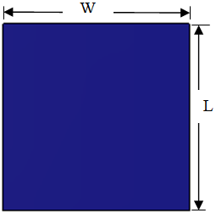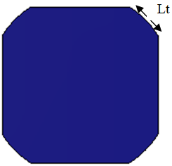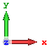

Figure 2.1 Geometry structure of (a) square patch (b) square patch with tapered edges [L=W=15mm and Lt=5mm].

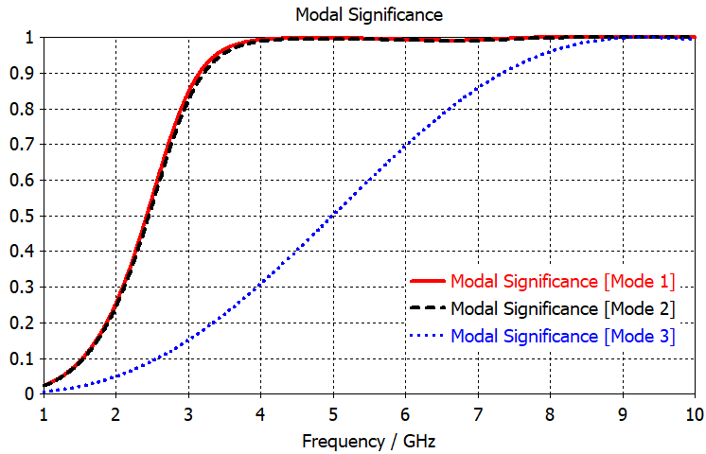

(a)

(b)

Figure 2.2 Simulated modal Significance curves of (a) square patch (b) square patch with tapered edges.

mode#1 mode#2 mode#3

**(a)**

The mode surface current distribution of the first three modes of the square patch is shown in Figure 2.3(a). In mode 1, more currents flow in the vertical direction on left and right edge surfaces, while in mode 2, more currents flow in the horizontal direction across the top and bottom edges. In mode 3, the current flow forms a loop-like distribution, which indicates that it stores energy instead of radiation.

# **2.2.1 Design of a Wideband Antenna**

Through the above analysis, the CMA allows us to change the size and shape of the radiating patch to modify the radiation properties to meet the required applications. It also provides information about the optimum feed position by analyzing the modal surface currents in order to excite the desired characteristic modes. According to the in-phase current distribution, the optimum feed position of the

# **2.3. Results and Discussion**

Use the time domain solver of the CST software tool to determine the simulation results of the proposed model, such as reflection coefficient, gain, efficiency, and radiation pattern. The reflection coefficient (S11) of the proposed wideband antenna is shown in Figure 2.6. The fractional bandwidth of 115% is obtained from 2.19 to 8.16 GHz with S11<-10 dB.

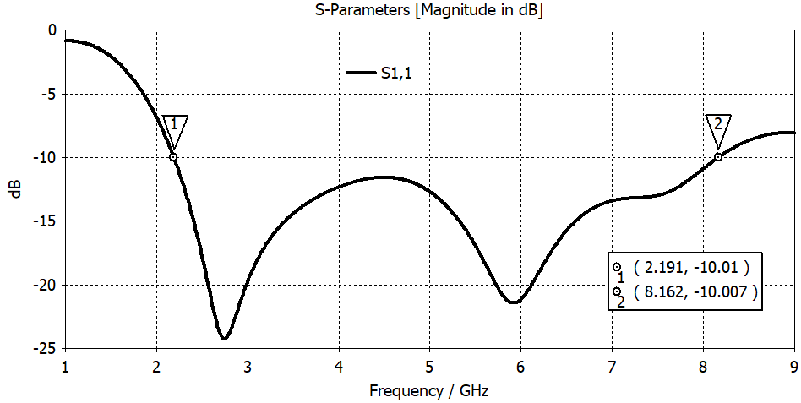

Figure 2.6 Simulated S11 parameter of the proposed wideband antenna.

**2.5 Conclusion**

A simple edge tapered microstrip square patch antenna has been designed using characteristic mode analysis for wideband communications. CMA provided deep insight into the radiation performance of the proposed wideband antenna to modify the antenna attributes and find the optimal feed position.

# **Acknowledgment**

The authors would like to thank their parents for their support and motivation, for without their blessings and God’s grace this paper would not be possible.

**References**

[1] R. K. Sharan, S. K. Sharma, A. Gupta, and R. K. Chaudhary," An Edge Tapered Rectangular Patch Antenna with Parasitic Stubs and Slot for Wideband Applications," Wireless Personal Communications., vol. 86, pp. 1213–1220, 2016.

[2] C. A. Balanis, “Antenna Theory: Analysis and Design," 3rd edition, Wiley, New York, NY, USA, 2005.

[3] R. DuHamel and F. Ore, “Logarithmically periodic antenna designs,” IRE International Convention Record., vol. 6, pp. 139–151, 1958.

[4] J. Dyson, “The characteristics and design of the conical log spiral antenna,” IEEE Transactions on Antennas and Propagation., vol. 13, no. 4, pp. 488–499, 1965.